  - MEDICAL DIAGNOSIS
AIM
To develop a medical diagnosis system using Prolog that identifies a possible disease based on the symptoms given by the user.
OBJECTIVE
- To represent medical knowledge using Prolog facts and rules.
- To accept symptoms as input.
- To apply logical inference for diagnosis.
- To display the possible disease based on matching symptoms.
ALGORITHM
- Start the program.
- Define symptoms as Prolog facts.
- Define diagnosis rules for different diseases.
- Enter the patient's symptoms.
- Match the symptoms with the predefined rules.
- If a rule matches, identify the possible disease.
- Display the diagnosis.
- If no rule matches, display an unknown diagnosis.
- Stop the program.

FLOWCHART
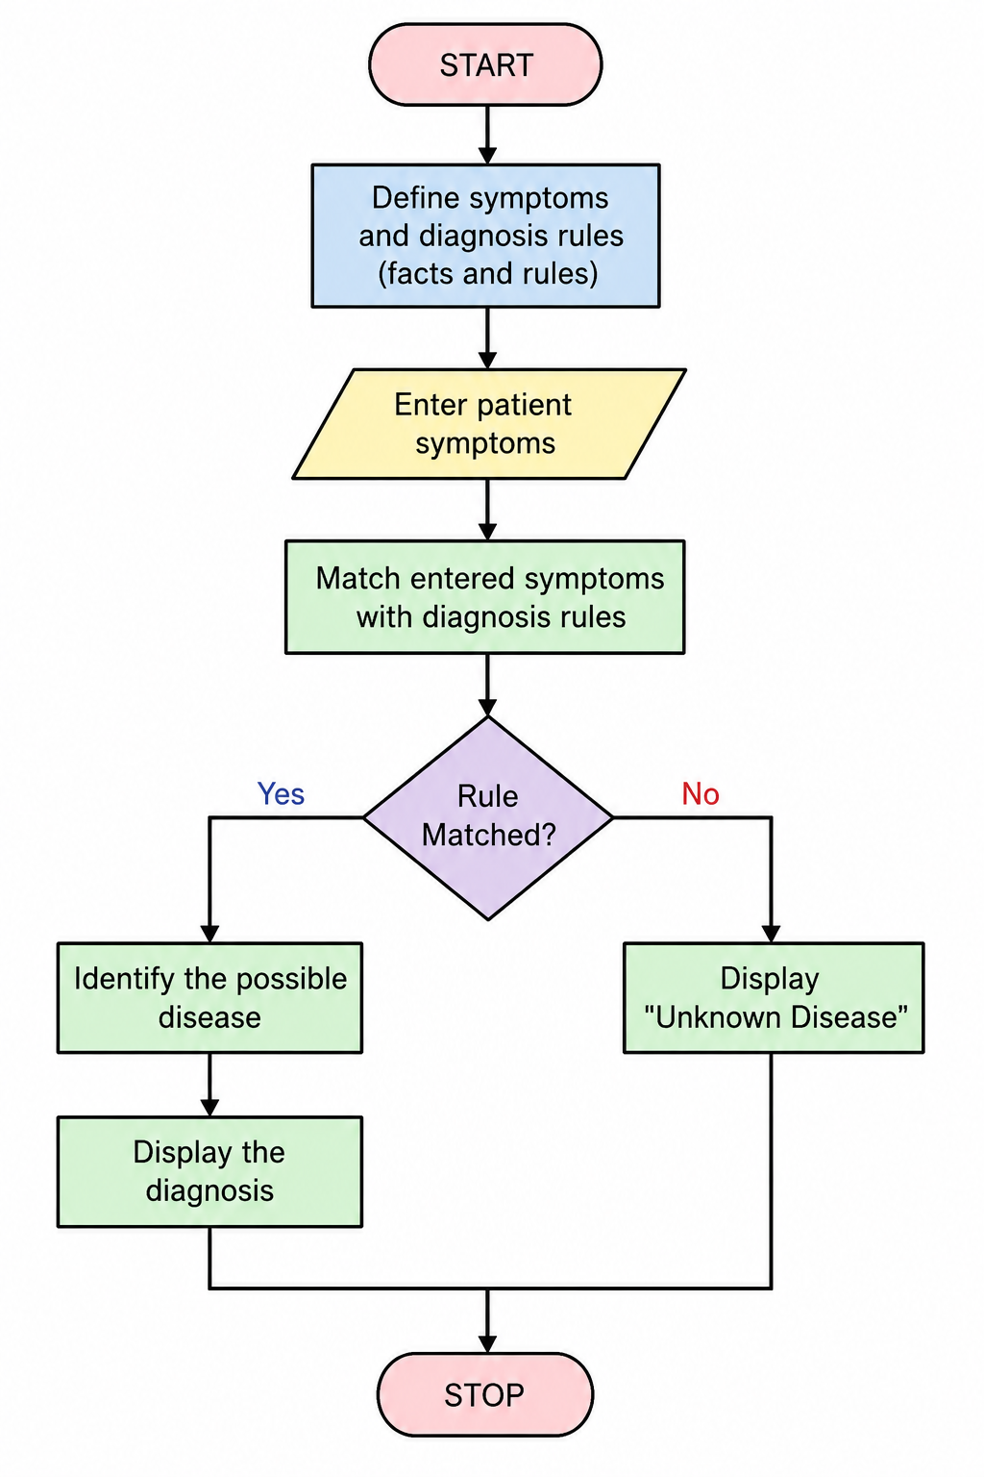
CODE
% Medical Diagnosis System
diagnosis(flu) :-
symptom(fever),
symptom(cough),
symptom(body_pain).
diagnosis(cold) :-
symptom(cough),
symptom(runny_nose),
symptom(sneezing).
diagnosis(malaria) :-
symptom(fever),
symptom(chills),
symptom(sweating).
diagnosis(typhoid) :-
symptom(fever),
symptom(headache),
symptom(abdominal_pain).
symptom(fever).
symptom(cough).
symptom(body_pain).
start :-
diagnosis(Disease),
write('Possible Diagnosis: '),
write(Disease),
nl.
OUTPUT
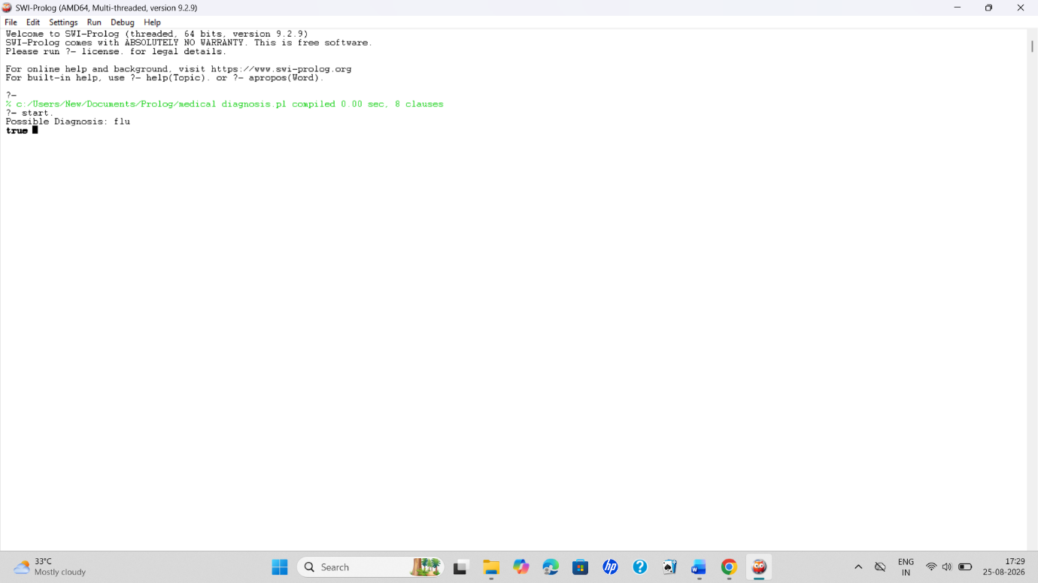
RESULT
The Prolog program for medical diagnosis was successfully implemented. The system uses symptoms, facts, and logical rules to identify a possible disease based on the given symptoms.

